Ally Meringer

ameringe

Recitation F

15-112 Term Project TP1

My project is a rubik’s cube solver. Ideally, I want to use OpenCV to scan in a rubik’s cube that my program would then solve. If I do not have time for the OpenCV component, I am going to have the user click on the different colors for each face. The screen would show a face of the cube, then say a move that the use needs to make, then display what the face would look like afterwards.

Ideally my program would be competitive with other rubik’s cube solvers because the OpenCV component would make it much easier. Also, the way I present steps would be easier because not only would I display the cube but I would say which face and which way to turn it for clarity. It would also make it very easy to follow because it will display the face before and after the move. Many rubiks cube solvers also just show what you should do in different cases but mine will be much more personalized.

Right now I am writing the solve function so I would put that in a file and import that into my animation code so that it could present as it goes. The cube is an object so I can keep track of the variables globally.

The algorithm I am using is the same one that I use mentally when I solve a rubik’s cube. This goes tier by tier. The first tier is the hardest because it uses the most intuition and intuition is obviously hard to code. After that, the second and third tiers are fairly easy to use an algorithm. I am also using indexing to figure out which color each piece is and where it needs to be moved to. After each move is made I am going to append the face before the move, the face after the move, and the name of the move to a mast list. Then, as the user presses the spacebar, the program will iterate through the list of moves.

I have finished the first tier so I would like to finish the second tier by Thursday and the last tier by Sunday. Then I will work on the user experience until TP2. After TP2 I am going to try Open CV.

I am backing up my code to my computer then iCloud. All new attempts at the new algorithm are saved in a new shell in the same Term Project Folder.

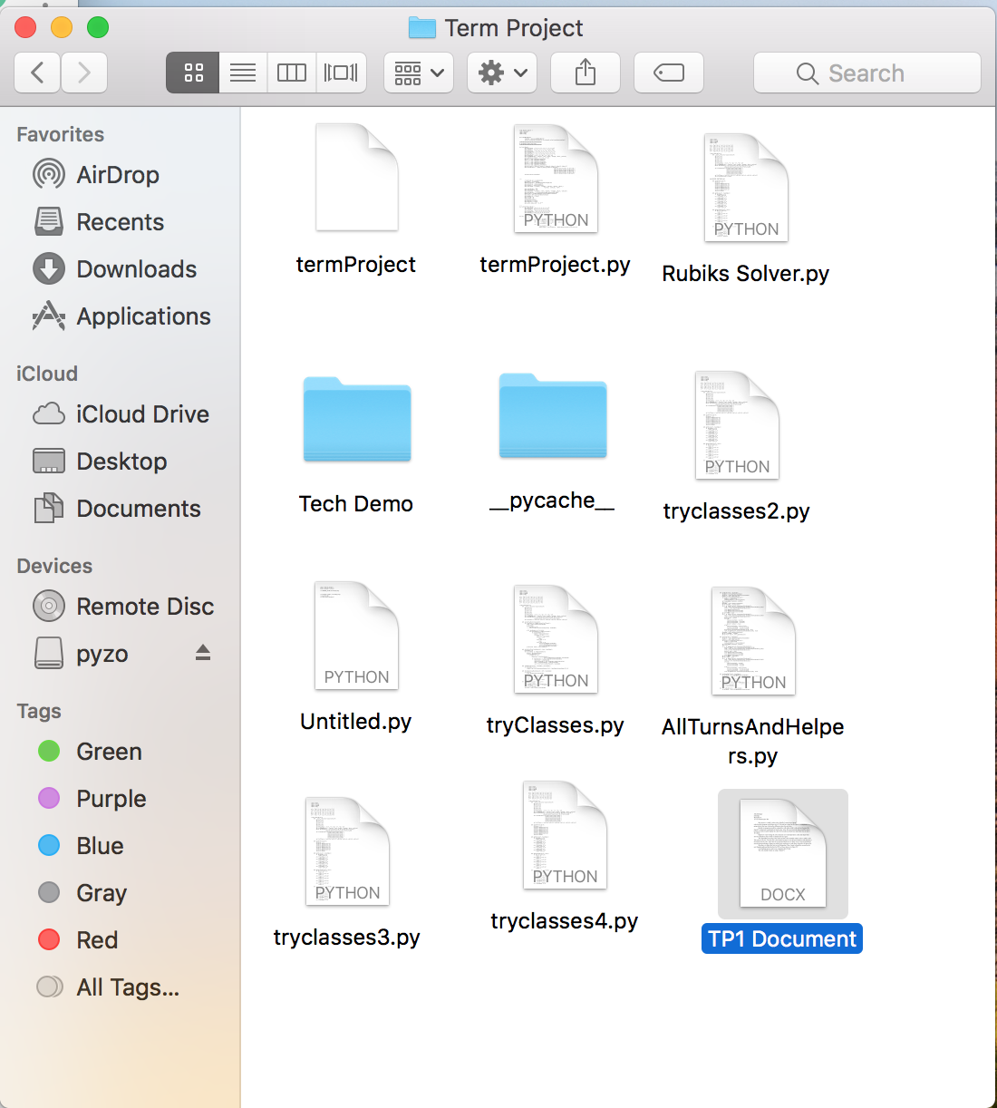

The only module I plan on using is OpenCV.

Storyboard (I apologize for my lack of artistic ability!!!):

